Template for Departmental Activity Report

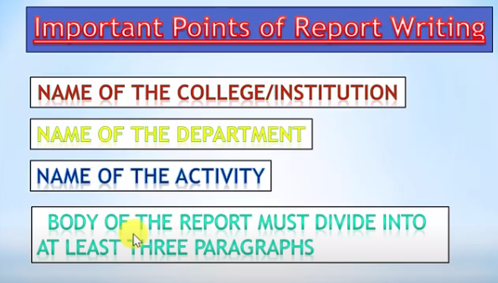
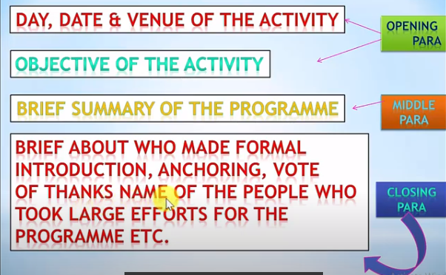
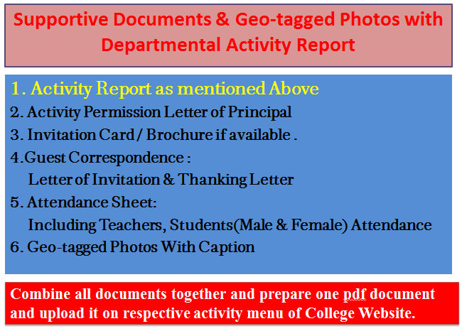
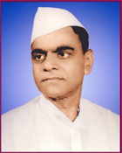
Janata Shikshan Sanstha’s
Kisan Veer Mahavidyalaya,Wai
Department of N. C. C.

Yoga Practice Camp for NCC Cadets
Report
As every year the International Day of Yoga is celebrated on 21st June. For the preparation “Yoga Practice Camp for NCC Cadets” was organized by the department of NCC between 5th to 20th June 2019 . The Guide at this practice Camp was Hon. Ashokrao Maltane, President, Satara Patanjali Yog Samiti. The Principal Dr. C. G. Yeole was the Chair person of the inaugural function of Yoga practice Camp. Dr. C. G. Yeole welcomed Hon. Ashokrao Maltan with a bouquet. Lieutenant Sameer Pawar welcomed Principal Dr. C. G. Yeole with a bouquet.

In his speech Ashokrao Maltane talked about yoga is an ancient practice of India. He again said that it is essential for every individual. He highlighted various types of yoga. He expressed his desire that everyone should adopt this habit. He explained how yoga can refrain life threatening diseases away.

Hon. Principal Dr. C. G. Yeole delivered his presidential speech in which he underlined the importance of yoga. Through his speech, he explained that yoga can help to live life happily.

Lieutenant Sameer Pawar gave an introductory speech explaining the significance of yoga. Eventually Mr Gajanan Jadhav, Director of Sports proposed the vote of thanks. 01 NCC Officer and 72 cadets attended this Camp.
After inaugural function of Yoga practice Camp Hon. Ashokrao Maltane conducted Yoga practice sessions every day between 8 to 10am.

College Seal
Dr. C. G. Yeole Lieutenant Sameer Pawar
Principal NCC Officer
Kisan Veer Mahavidyalay,Wai NCC Unit
2. Activity Permission Letter of Principal

Paste the PDF

4. 4.Guest Correspondence:
Letter of Invitation & Thanking Letter

Paste the PDF
3. Invitation Card / Brochure if available

Paste the PDF

Combine all documents together and prepare one pdf document and upload it on respective activity menu of College Website.
Caption
Caption
Paste the PDF
Paste the PDF
Caption
Caption
Paste the PDF
Paste the PDF
5. Geo-tagged Photos With Caption

Paste the PDF
5. Attendance Sheet:
Including Teachers, Students
(Male & Female) Attendance

